APPENDIX B

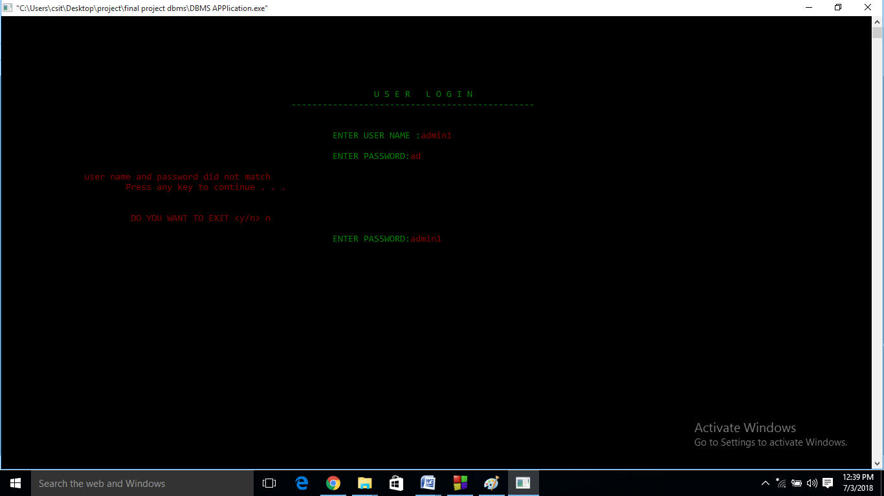

*Fig : screen shot of administration login page*

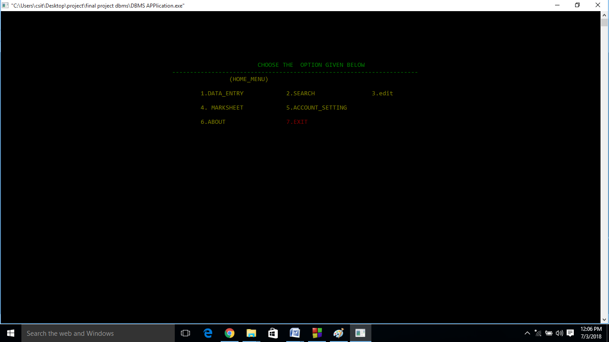

*Fig : screenshot of home_menu page*

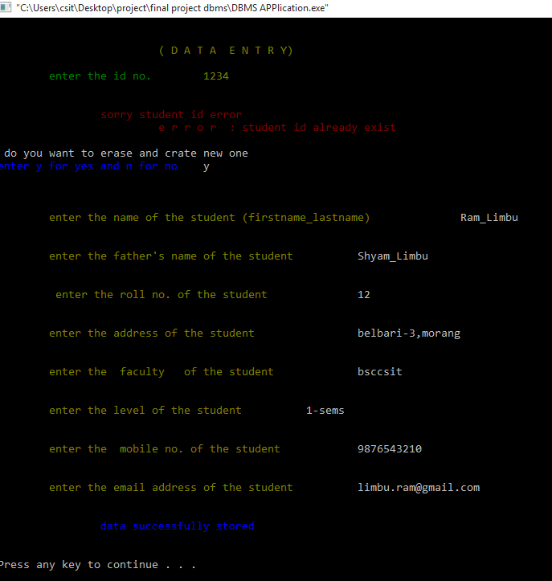

*Fig: screenshot of Data_entry page*

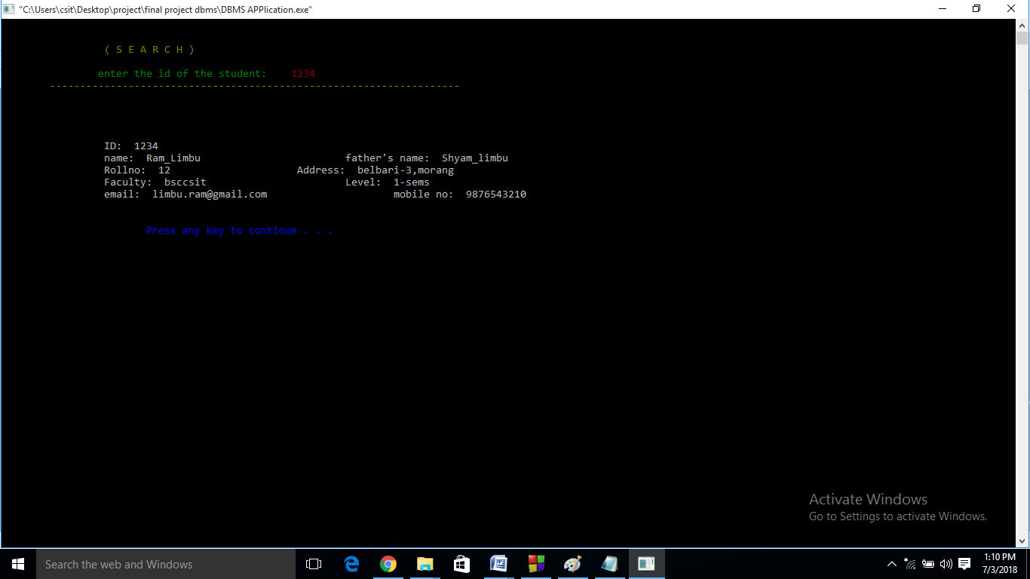

*fig: screenshot of search menu*

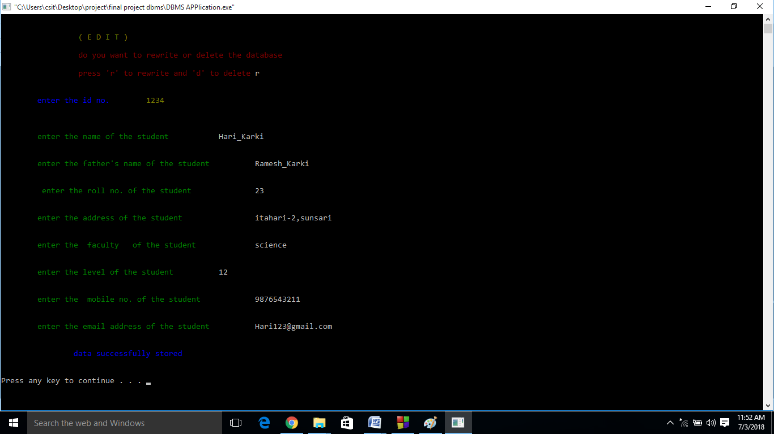

*Fig :screen shot of edit menu*

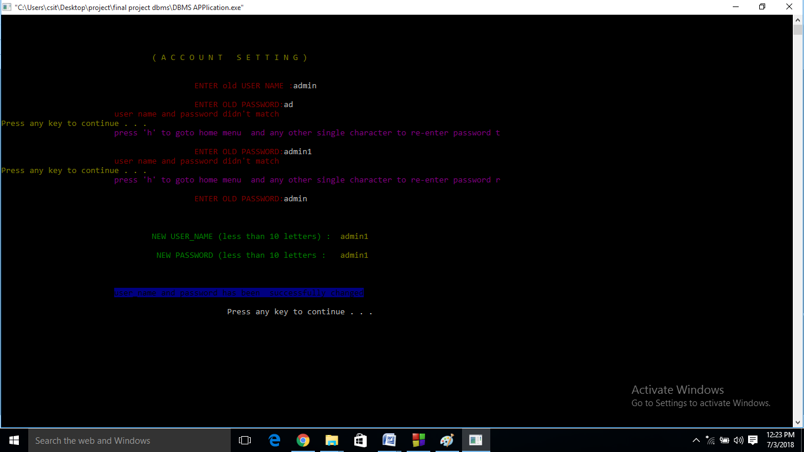

*Fig :screenshot of account setting*

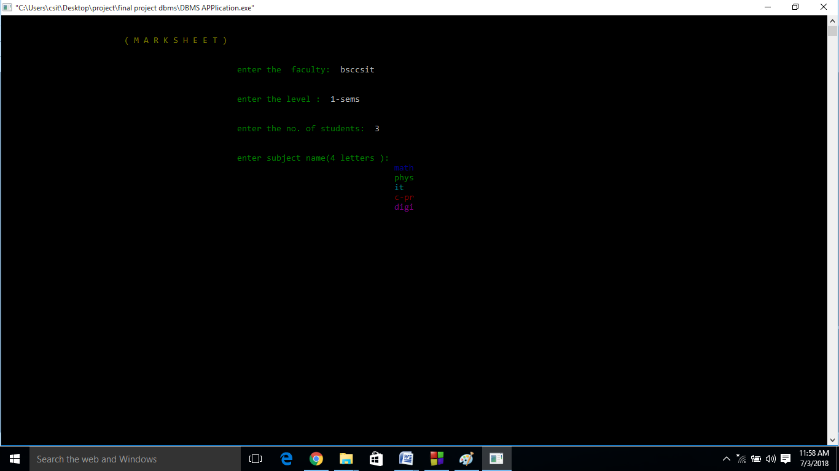

*Fig:screenshot of Marksheet (first screen)*

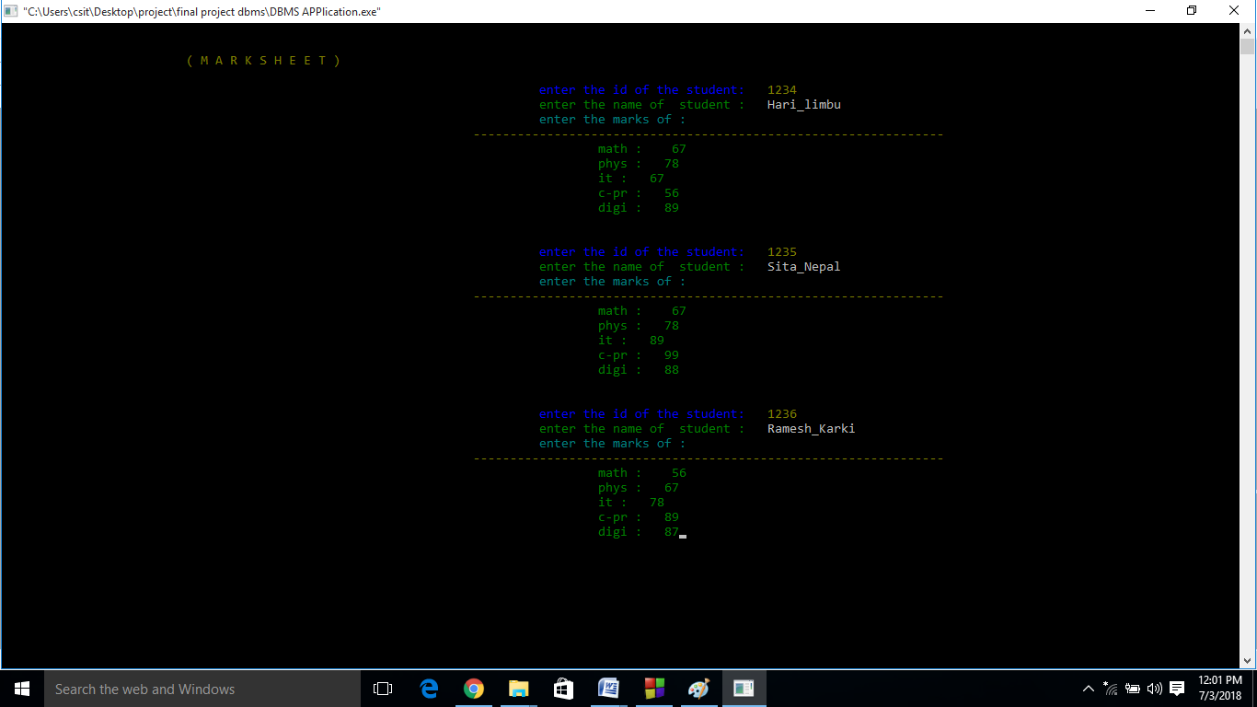

*Fig :screenshot of Marksheet (second screen)*

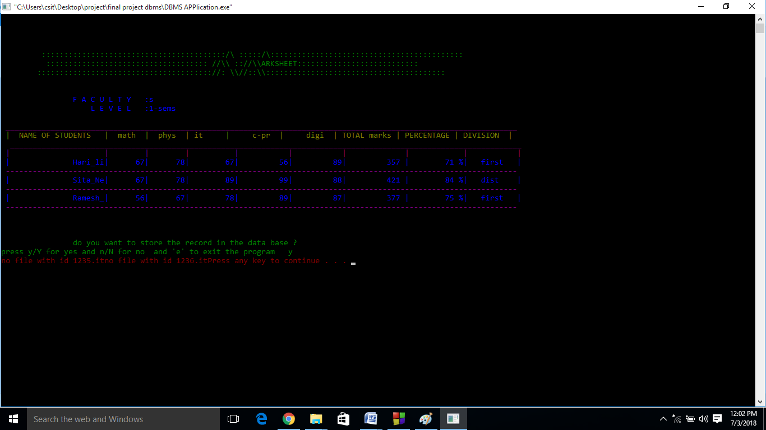

*Fig:screenshot of Marksheet (third screen)*

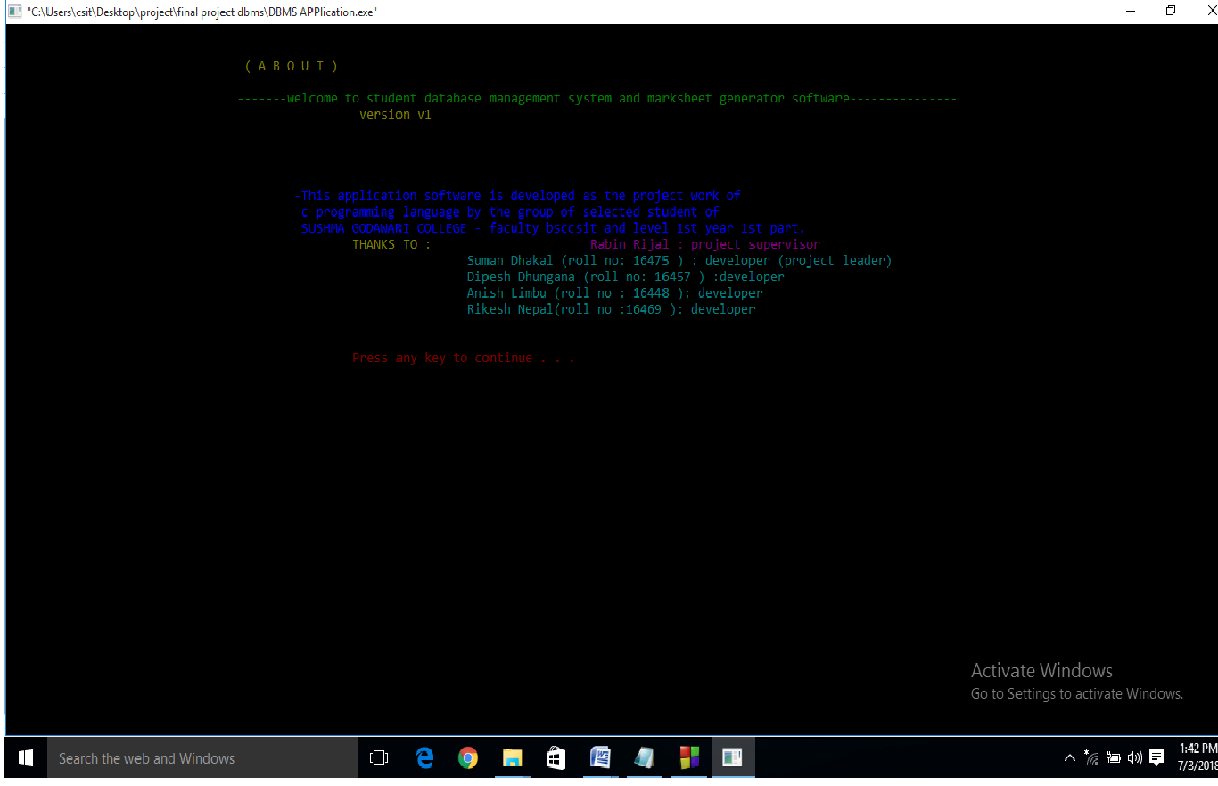

*Fig: screenshot of ABOUT page*